**Problem statement ::- Recommend a best book ratings.**

#book rating data

> book_rate_data1 <- read.csv("book.csv")

> View(book_rate_data1)

> book_rate_data <- book_rate_data1[-c(1,2)]

> View(book_rate_data)

> #metadata about the variable

> str(book_rate_data)

'data.frame': 10000 obs. of 2 variables:

$ Book.Title : chr "Classical Mythology" "Clara Callan" "Decision in Normandy" "Flu: The Story of the Great Influenza Pandemic of 1918 and the Search for the Virus That Caused It" ...

$ Book.Rating: int 5 3 6 8 6 7 10 9 9 8 ...

>

> #rating distribution

> hist(book_rate_data$Book.Rating)

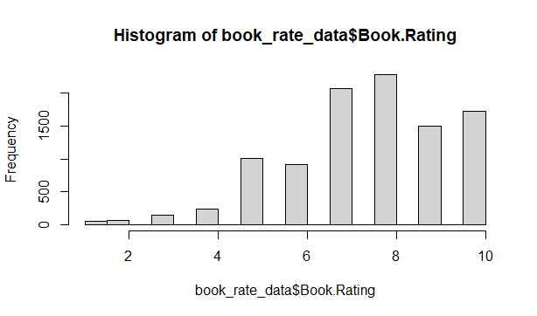

>

> #the datatype should be realRatingMatrix inorder to build recommendation engine

> book_rate_data_matrix <- as(book_rate_data, 'realRatingMatrix')

> #Normalize the ratings matrix

> #Predictions for two users

> recommended_items1 <- predict(book_recomm_model1, book_rate_data_matrix[413:414], n=5)

> as(recommended_items1, "list")

$`AixÃ² Ã©s RÃ dio Pica (ColÂ¨lecciÃ³ Embat)`

[1] "8" "9" "5" "3" "6"

$`AkÃ©: The years of childhood (Aventura : the Vintage library of contemporary world literature)`

[1] "8" "9" "5" "3" "2"

>

>

> ## Popularity model recommends the same books for all users , we need to improve our model using

> # # Collaborative Filtering

>

> #1.User Based Collaborative Filtering Creation of the model U(ser) B(ased) C(ollaborative) F(iltering)

>

> book_recomm_model2 <- Recommender(book_rate_data_matrix, method="UBCF")

>

>

> ##*******Predictions for two users **********

> recommended_items2 <- predict(book_recomm_model2, book_rate_data_matrix[413:414], n=5)

> as(recommended_items2, "list")

$`AixÃ² Ã©s RÃ dio Pica (ColÂ¨lecciÃ³ Embat)`

[1] "4"

$`AkÃ©: The years of childhood (Aventura : the Vintage library of contemporary world literature)`

[1] "5" "8" "9"

> Rec.model=Recommender(book_rate_data_matrix[413:414],method="UBCF",

+ param=list(normalize = "Z-score",method="Cosine",nn=5, minRating=1))

Warning: Unknown parameters: minRating

Available parameter (with default values):

method = cosine

nn = 25

sample = FALSE

weighted = TRUE

normalize = center

min_matching_items = 0

min_predictive_items = 0

verbose = FALSE

>

>

> #2.Matrix factorization with LIBMF*************

>

> book_recomm_model3 <- Recommender(book_rate_data_matrix, method="LIBMF")

> ##********Predictions for two users

> book_recomm_model3 <- predict(book_recomm_model3, book_rate_data_matrix[413:414], n=5)

iter tr_rmse obj

0 0.8779 8.2995e+03

1 0.5779 3.8433e+03

2 0.2469 1.0735e+03

3 0.1298 6.3370e+02

4 0.1211 6.1077e+02

5 0.1193 6.0665e+02

6 0.1160 5.9809e+02

7 0.1141 5.9523e+02

8 0.1118 5.8948e+02

9 0.1105 5.8589e+02

10 0.1087 5.8142e+02

11 0.1069 5.7757e+02

12 0.1047 5.7232e+02

13 0.1029 5.6953e+02

14 0.1000 5.6308e+02

15 0.0987 5.6076e+02

16 0.0962 5.5626e+02

17 0.0957 5.5448e+02

18 0.0939 5.5129e+02

19 0.0922 5.4738e+02

>

> ###****3. RANDOM recommendations

> book_recomm_model4 <- Recommender(book_rate_data_matrix, method="RANDOM")

> ##***Predictions for two users ***********

> recommended_items4 <- predict(book_recomm_model4, book_rate_data_matrix[413:414], n=5)

> as(recommended_items4, "list")

$`AixÃ² Ã©s RÃ dio Pica (ColÂ¨lecciÃ³ Embat)`

[1] "9" "1" "3" "2" "4"

$`AkÃ©: The years of childhood (Aventura : the Vintage library of contemporary world literature)`

[1] "10" "7" "4" "8" "1"